Rigging Equipment Inspection Checklist
This Rigging Equipment Inspection Checklist includes inspection requirements for all sling types (i.e., wire rope, alloy steel chain, metal mesh, natural and synthetic fiber rope, and synthetic wire) and hardware fastening components (e.g., shackles, bolts, swivels, hooks, etc.).
Instructions: Each day before being used, you must ensure that the sling and all fastenings and attachments are inspected for damage or defects by a competent person. Additional inspections must be performed during sling use where service conditions warrant, such as high heat temperatures. You must immediately remove damaged or defective slings from service.
Document rigging equipment inspections at least annually. Keep records on file for one year.
Your name: _____________________________ Date/time: __________________________
Location: ________________________________________________________________________
Unit/department: ________________________________________________________________

Wire Rope Sling/Rigging Inspection
If applicable, please complete the table below. If not applicable, check this box .
Slings shall have a manufacturer’s label showing the rated capacity. Do not exceed rated capacity.
Remove from service if any of the following apply: | Yes | No
10 randomly distributed broken wires in 1 rope lay, or 5 broken wires in 1 strand in 1 rope lay (refer to Figure 1 below)
Wear or scraping of 1/3rd the original diameter of outside individual wires
Distortion such as kinking, crushing, bird caging, displace wires
Evidence of heat damage from any cause
End attachments that are cracked, deformed, or worn
Hooks have been opened >15% of normal throat opening or twisted >10 degrees
Additional Information:
Figure 1: Wire rope components.
Created by Phillip Toone, OSHA DTSEM/SLTC
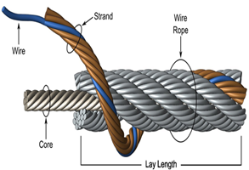
1. Use sling protection and avoid load slippage.
2. Don’t choke on fittings, avoid pinch points.
3. Don’t place sling eye on large hook.
WAC 296-24-29425

Alloy Steel Chain Slings
If applicable, please complete the table below. If not applicable, check this box .
Do not exceed rated capacity. Slings shall have a manufacturer’s label with size, grade, rated capacity, and reach.
Remove from service and discard if any of the following apply: | Yes | No
Sling has been heated above 1000 °F.
Cracked or deformed master links, couplings, or other components
Hooks have been opened >15% of normal throat opening or twisted >10 degrees.
Additional information:
1. Makeshift links or fasteners made from bolts or rods must not be used.
2. Mechanical coupling or low carbon steel repair links must not be used to repair broken lengths of chains.
3. Prior to use, all welded or mechanical components of new slings must be roof tested by the Manufacturer to twice the rated load. Proof test certificates can be requested of the manufacturer, if needed.
4. Latches on hooks must “seat properly, rotate freely, and show no permanent distortion.”
WAC 296-24-29423
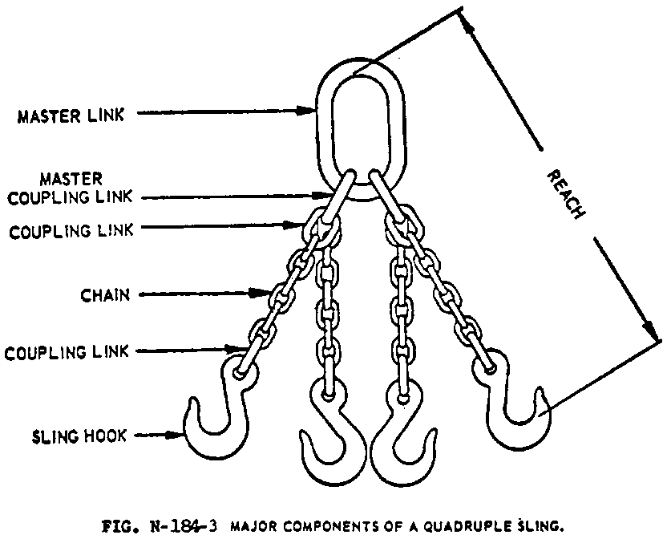
Figure 2: Multi-leg sling (osha.gov 1910.184)

Synthetic Web Slings
If applicable, please complete the table below. If not applicable, check this box .
Slings shall have a manufacturer’s label showing the rated capacity. Do not exceed rated capacity.
Do not use nylon web or aluminum fittings near acid. Do not use polyester web around caustics.
Stitching is the only acceptable method to attach end fittings and form eyes.

Remove from service if any of the following apply: | Yes | No
Acid or caustic burns
Melting or charring of any part of the sling surface
Snags, punctures, tears, or cuts
Broken or worn stiches
Distortion of fittings
Additional Information:
1. Use sling protection between edges and sling.
2. Do not shorten or lengthen using knots.
WAC 296-24-29431
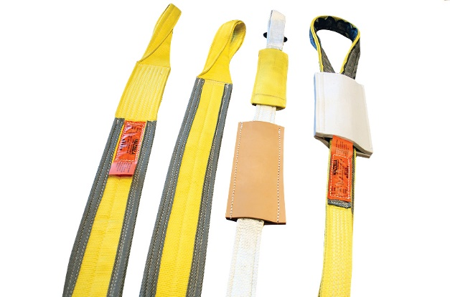
Figure 3: Synthetic slings
Source: mazzellacompanies.com

Metal Mesh Slings
If applicable, please complete the table below. If not applicable, check this box .

Remove from service if any of the following apply: | Yes | No
A broken weld or broke brazed joint along the sling edge
Lack of flexibility due to distortion of the fabric
Distortion of the female handle so that the width of the eye is decreased more than 10%
Distortion of either handle so that the width of the eye is decreased more than 10%
A 15% reduction of the original cross-sectional area of metal at any point around the handle eye
Distortion of either handle out of its plane

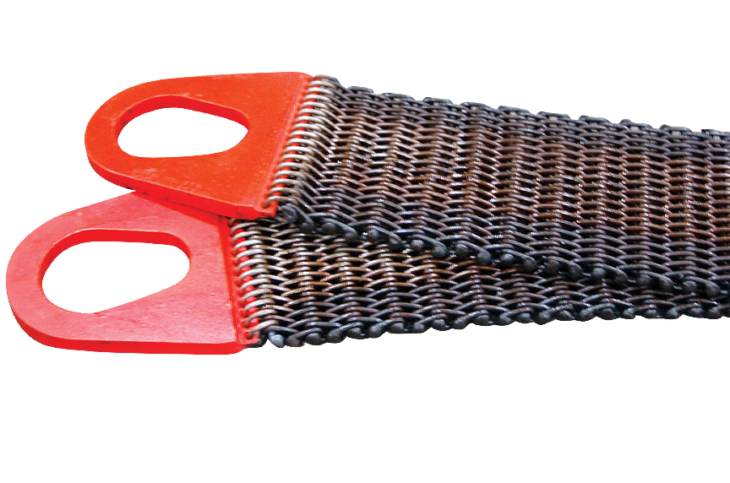
WAC 296-24-29427

Figure 4: Wire mesh slings
Source: mazzellacompanies.com

Natural and Synthetic Fiber Rope Slings
If applicable, please complete the table below. If not applicable, check this box .
Repairs: You must only use fiber rope slings made from new rope. Use of repaired or recondition fiber rope slings is prohibited.
Remove from service if any of the following apply: | Yes | No
Abnormal wear
Powdered fiber between strands
Broken or cut fibers
Variations in the size or roundness of strands
Discoloration or rotting
Distortion of hardware in the sling
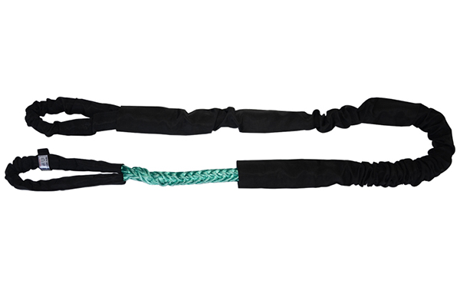
WAC 296-24-29429

Figure 5: Synthetic fiber rope sling
Source: amazon.com

Rigging Accessories - Shackles, swivels, and hoist rings
If applicable, please complete the table below. If not applicable, check this box .

Remove from service if any of the following apply: | Yes | No
Indications of heat damage, including weld spatter or arc strikes
Excessive pitting or corrosion
Excessive nicks or gouges
10% reduction of the original (or catalog) dimension at any point
Excessive thread damage or wear
On shackles, also inspect for incomplete pin engagement
On swivels and hoist rings, check for lack of ability to freely rotate or pivot
WAC 296-155-55600
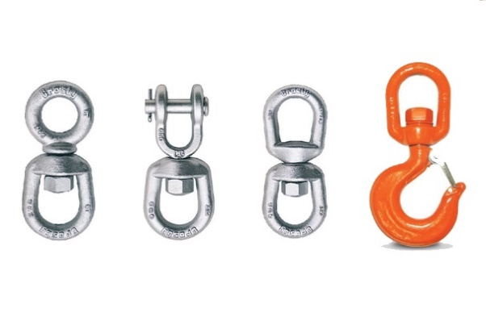

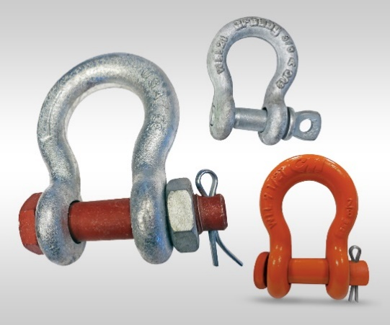
Figure 7: Various shackles
Source: mazzellacompanies.com
Figure 6: Hardware fasteners; swivels, hooks
Source: mazzellacompanies.com

